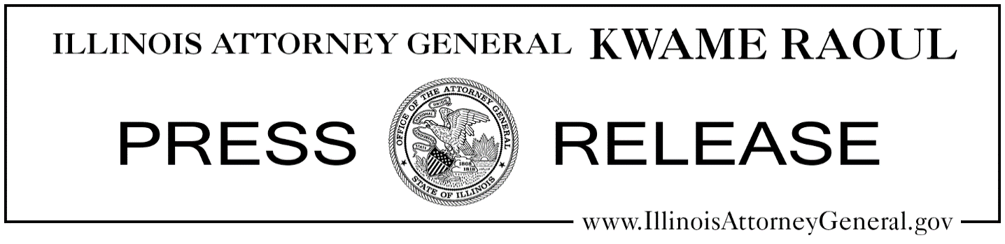

**For Immediate Release: Contact:**

March 16, 2022 [PressOffice@ilag.gov](mailto:PressOffice@ilag.gov)

217-785-5726

*@ILAttyGeneral*

**ATTORNEY GENERAL RAOUL FILES LAWSUIT AGAINST 3M OVER CONTAMINATION BY TOXIC “FOREVER CHEMICALS”**

**Chicago** – Attorney General Kwame Raoul today filed a lawsuit against 3M alleging that the company’s improper handling of per- and polyfluoroalkyl substances (PFAS) – also known as “forever chemicals” for their persistence in the environment – resulted in ongoing contamination at and around its facility in Cordova, Illinois.

[Raoul’s lawsuit](https://www.illinoisattorneygeneral.gov/pressroom/2022_03/Raoul_v_3M_Complaint_3_15_22_Final_with_AJL_Signature.pdf) was filed in Rock Island County Circuit Court alleging that 3M’s negligent operations at its facility in Cordova have resulted in significant levels of PFAS contamination at and around the facility, which is located on the banks of the Mississippi River. Attorney General Raoul’s lawsuit further alleges that despite being aware of the health and environmental hazards connected to PFAS, 3M has downplayed negative impacts. The Attorney General’s office is partnering on the case with a team of outside counsel who have been designated as special assistant attorneys general.

“For decades, 3M has been aware of the dangers of PFAS, or ‘forever chemicals.’ Despite scientific evidence generated by its own research, 3M downplayed or denied the health and environmental hazards connected to PFAS, and even promoted these toxic chemicals as being safe to manufacture,” Raoul said. “3M must be held accountable for the contamination its operations in Cordova have caused. This lawsuit is an important step toward accountability and protecting the surrounding environment and public health.”

3M has owned and operated its Cordova facility since approximately 1970. It is one of three facilities where 3M manufactures a number of chemical products including adhesives, resins, fluorochemicals and other specialty chemicals. Raoul’s lawsuit alleges that 3M was aware as early as the 1960s that PFAS are toxic and do not biodegrade in the environment. Further 3M testing throughout the 1970s confirmed the toxicity of PFAS to aquatic wildlife, including fish species. Despite that, 3M continued to manufacture, discharge and dispose of PFAS at the Cordova facility, while it promoted PFAS as being safe to manufacture and use. On its website, 3M continues to deny the adverse health and environmental impacts of PFAS.

“Illinois EPA is working closely with the Attorney General’s office to provide necessary evidence on the extent of PFAS contamination that has impacted ground and surface waters,” said Illinois EPA Director John J.  Kim. “Holding 3M responsible for their actions is important as we continue to assist in this process to ensure the contamination is addressed properly by the facility.”

Attorney General Raoul’s lawsuit alleges that 3M’s Cordova operations, specifically leaked and spilled PFAS and PFAS-containing waste, have resulted in significant levels of PFAS contamination. Sampling conducted by 3M, the U.S. Environmental Protection Agency and the Illinois Environmental Protection Agency (IEPA) has confirmed the presence of contaminated groundwater under and around the facility, as well as the Mississippi River. Testing done at one groundwater monitoring well in 2020 showed PFAS levels several thousand parts per trillion higher than proposed state standards. In addition, 3M discharges more than 8 million gallons of contaminated wastewater directly into the Mississippi River each day, and wastewater sampling has shown levels of toxic PFAS in the wastewater.

PFAS are human-made, synthetic chemicals that do not exist naturally in the environment. PFAS are highly toxic to humans and animals, and they are extremely resistant to degradation in the environment, which is why PFAS are known as “forever chemicals.” PFAS contaminants may be linked to serious adverse health effects in humans and animals, including increased serum cholesterol, immune dysregulation, pregnancy-induced hypertension, and kidney and testicular cancers. Exposure to certain types of PFAS is also associated with low birth weight in babies, suppressed immune system response, dyslipidemia, impaired kidney function and delayed onset of menstruation.

Raoul’s lawsuit seeks to require 3M to address PFAS contamination and protect public health and the environment. The lawsuit also seeks civil penalties of up to $50,000 for each violation of the Illinois Environmental Protection Act and associated regulations, and additional civil penalties of $10,000 for each day the violations continue. In addition, the lawsuit seeks damages arising from PFAS contamination and injury of natural resources.

Division Chief Matthew Dunn, Bureau Chief Stephen Sylvester and Deputy Bureau Chief Gerald Karr, along with Senior Assistant Attorney General Ellen O’Laughlin and Assistant Attorney General Karen Howard are handling the case for Raoul’s Environmental Bureau. In addition, attorneys representing DiCello Levitt Gutzler LLC, Keating Muething & Klekamp PLL, and Fields PLLC will co-prosecute the case as special assistant attorneys general.

-30-